**Weekly Status Report - 2018-MAY-08**

|  |  |
| --- | --- |
| **Project Name** | BiFrost Games |
| **Team Lead** | Pat Horler |

|  |  |  |  |
| --- | --- | --- | --- |
| **Roles** |  |  |  |
| **Week** | **<Pat Horler>** | **<Curtis Naples>** | **<Evan Plant>** |
| 01 | Project Lead, Technical Writer | Technical Writer | Technical Writer |
| 02 |  |  |  |
| 03 |  |  |  |
| 04 |  |  |  |
| 05 |  |  |  |
| 06 |  |  |  |
| 07 |  |  |  |
| 08 |  |  |  |

|  |  |  |
| --- | --- | --- |
| **Roles** |  |  |
| **Week** | **<Devan Weber>** | **<Illia Kara>** |
| 01 | Technical Writer | Technical Writer |
| 02 |  |  |
| 03 |  |  |
| 04 |  |  |
| 05 |  |  |
| 06 |  |  |
| 07 |  |  |
| 08 |  |  |

|  |
| --- |
| **Weekly Project Summary** |
| Began work on BiFrost Games requirements. Project is ahead of schedule, no issues.  BRD sections 1-4 completed, Gantt chart started, Project Charter completed. |

|  |  |  |  |  |  |
| --- | --- | --- | --- | --- | --- |
| **Key Milestones Status** | | | | | |
| **ID** | **Description** | **Planned Completion** | **Forecasted**  **Completion** | **Actual Completion** | **Status** |
| MS01 | BRD Complete | 2018-MAY-15 | 2018-MAY-08 | 2018-MAY-08 | Closed |
| MS02 | Demo Ready | 2018-MAY-15 | 2018-MAY-12 | 2018-MAY-15 | Closed |
| MS03 | Deliverables Ready | 2018-MAY-25 | 2018-MAY-15 | 2018-MAY-15 | Closed |
|  |  |  |  |  |  |
|  |  |  |  |  |  |
|  |  |  |  |  |  |
|  |  |  |  |  |  |

|  |
| --- |
| **Key Accomplishments for the Week** |
| * Project Charter Completed * BRD (Sections 1-4) Completed * Week 1 and 2 of Gantt Chart Completed * UI Mock-up Started |

|  |  |  |  |
| --- | --- | --- | --- |
| **Task Assignments for the Coming Week** | | |  |
| **ID** | **Description** | **Assigned To** | **On Schedule** |
| T02.5 | BRD Section 5 | Pat, Illia, Curtis | Yes |
| T02.6 | BRD Section 6 | Curtis | Yes |
| T05 | Git Repository Report | Evan | Yes |
| T06 | Build DB | Devan(TL), Evan, Pat, Curtis, Illia | Yes |
| T07 | Continue Gantt Chart | Devan(TL) | Yes |
| T08 | Weekly Task Report | Devan(TL) | Yes |
|  |  |  |  |

|  |  |  |
| --- | --- | --- |
| **Task Completed in the Previous Week** | |  |
| **ID** | **Description** | **Assigned To** |
| T01 | Project Charter | Devan |
| T02.1 | BRD Section 1 | Curtis |
| T02.2 | BRD Section 2 | Curtis |
| T02.3 | BRD Section 3 | Evan |
| T02.4 | BRD Section 4 | Pat, Curtis, Evan, Devan, Illia |
| T04 | Weekly Task Report | Pat |
|  |  |  |

|  |  |
| --- | --- |
| Issues and Risks |  |
| **Description** | **Impact**  **(L,M,H)** |
|  |  |
|  |  |
|  |  |

|  |
| --- |
| **Gantt Chart** |

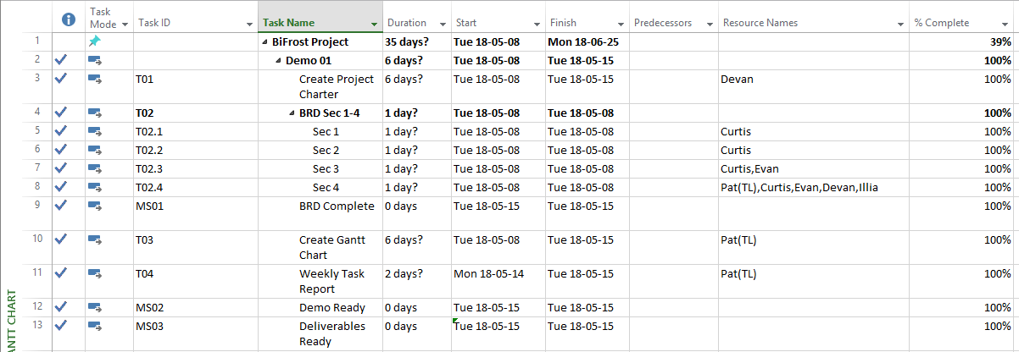

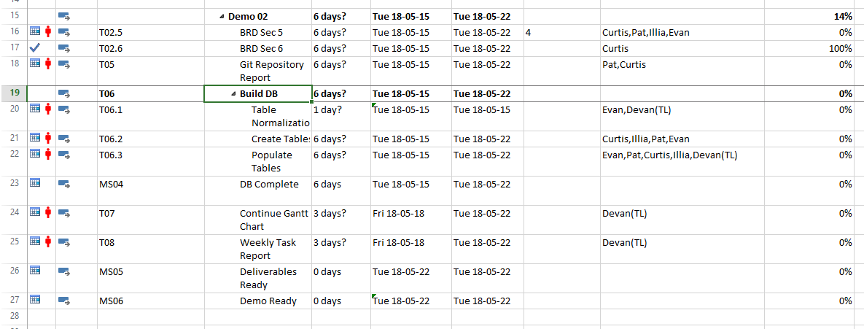

|  |
| --- |
| **Git Log** |

*< Insert Git Log here, use the following command*

*git log --since=1.week --pretty=format:"%an: %s"*

*>*

N/A. Git repository not created.